- Auto-Boxing
  - 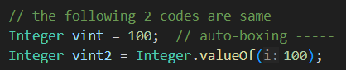
  - It is auto-boxing,
  - When we assign any primitive value to wrapper class (just like here assigning int value (100) to wrapper (Integer)). under the hood it is getting converted using that valueOf method.
  - Integer.valueOf() method takes int value as an argument and return one Integer type of object in return.
- Auto-unboxing
  - 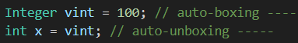
  - It is auto-unboxing.
  - Here, the wrapper type (Integer) is getting converted to primitive type (int).
  - 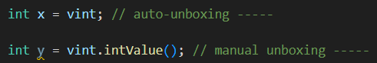
  - This is what happens under the hood. intValue method returns the primitive i.e. int value of the wrapper i.e. Integer.

GENERIC
- The below is one non-generic class.
  - 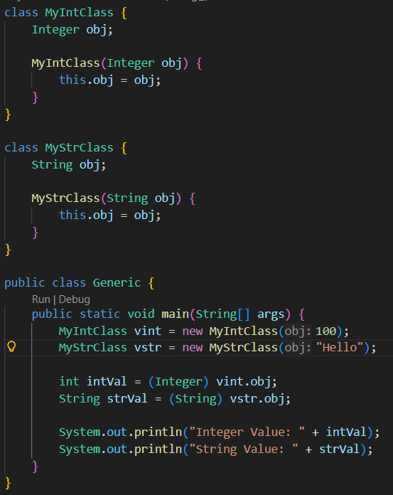
  - In here, for the same operations, we need to create different different classes for different types of data types. To overcome this issue, we can use Generic classes.
- The below is the example with Generic class.
  - 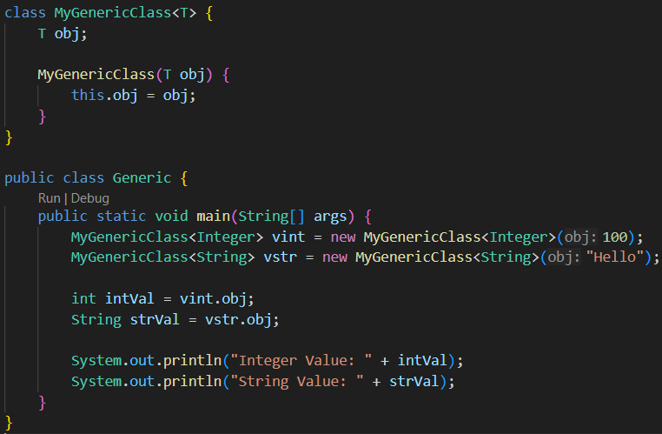
  - <T> denotes the Object type.
  - Generic type cannot take primitive type. It only takes the Objects (i.e. wrappers).
- In the below example you can see if one class/interface is implementing/inheriting another interface or class, then it should include the class for the generic class.
  - 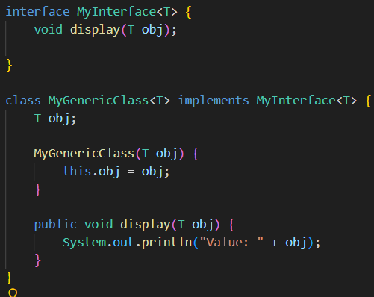
  - MyInterface<T> is mentioned with the MyGenericClass<T>
- You can give multi-letter generic type as well. But the convention is to use single letter.
  - 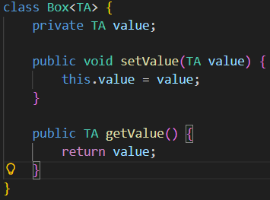

- Multiple types can also be used.
  - 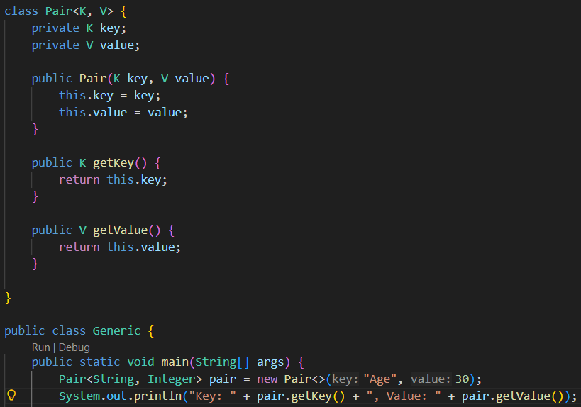
- Conventions:
  - T : Type
  - K, V : Key and Value in case of maps
  - E : Element (Used in Collections)
  - N : Number

- In the below example, I used T in the implemented interface and in the methods as well. But didn’t defined it; So, it’ll give me error.
  - 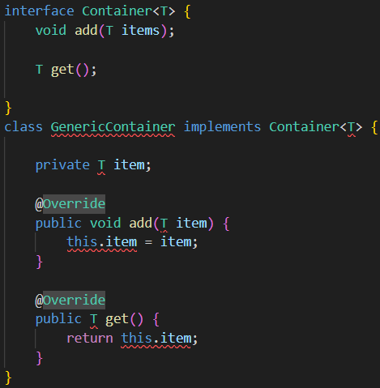
  - 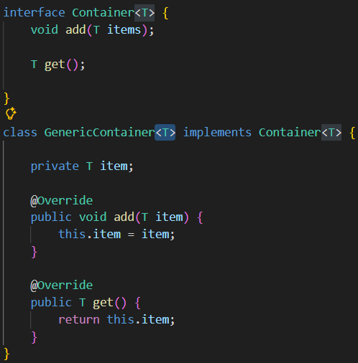
    - Now it is fixed.

- Bounded type
  - It means the object type should be such that it will be inheriting one Class or/and implementing one/more interface(s).
  - 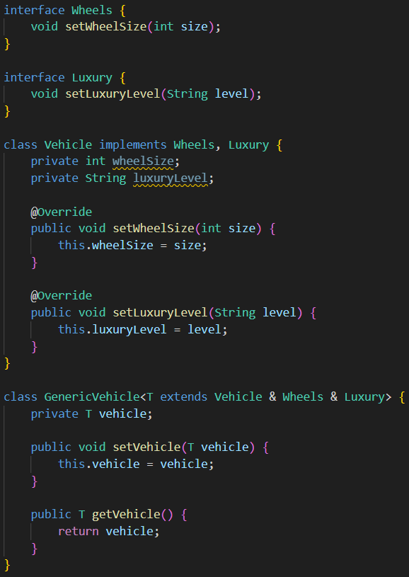
  - T extends class & interface1 & interface2
  - If you only want T to implement only interfaces then:
    - T extends interface1 & interface2 (NOTE: extends keyword will be used)
  - The class should be written first (if you want T to extend some class); If you write class in 2nd or 3rd or… after places, it’ll assume that that is interface (not class)
    - 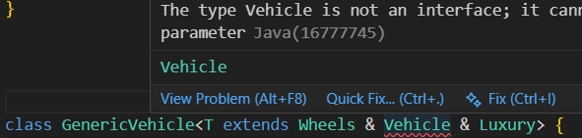
  - First one can be class or interface doesn’t matter; but after first, it must be interfaces.
    - The reason is, in java, multiple inheritance is not supported; extending multiple classes won’t be allowed; so if you want, then write the class in the first place then go ahead with the interfaces.
  - Here you can say why to write like this T extends SomeClass, we can directly write SomeClass and we can use SomeClassB instead of that T; but what is the problem?
    - Lets consider the below example:
    - 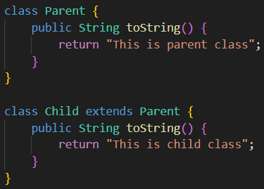
      - I have 2 classes; Parent and Child. Child extens Parent class.
    - 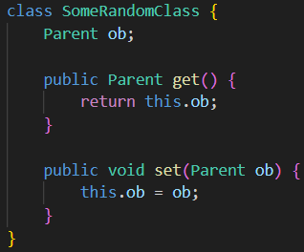
      - This class accepts Parent type values; so we can also use Child values here.
    - 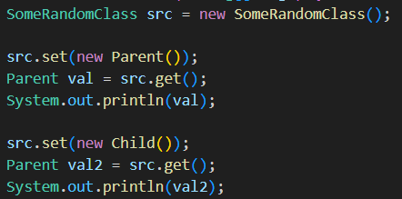
      - Here it is perfectly fine because we are keeping the return value of get method in a variable of type Parent.
      - And also, in the class SomeRandomClass, the variable is of type Parent so it can store Child type objects without doing upcasting explicitely.
      - NOTE: upcasting happens by default; but for downcasting, you need to explicitely mention.
    - 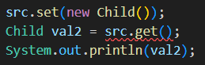
      - Now it’ll fail, because get method is returning one Parent type object and we are creating variable of Child type.
      - 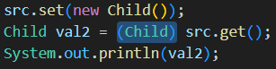
      - Now it’ll work properly because we did downcasting here.
    - Now, the problem is, why to use this downcasting and upcasting ; its not generic anymore.
    - 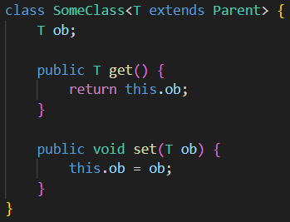
      - I have one more class here which is using generic type T which needs to inherit the Parent class.
      - One more thing, T extends Parent means, T can be Parent itself or any subclass of Parent.
      - 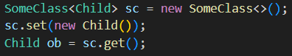
      - Now it’ll perfectly work.

Generic Constructor
- If we don’t want to explicitly write any generic type T for the whole class, but just want to use the generic for the constructor then we can do this like below:
    - 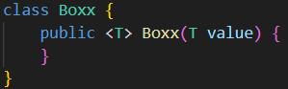
    - 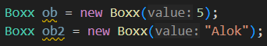
      - You can use like this.
- Generic Method
  - 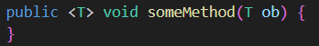
    - Return type is: void
  - 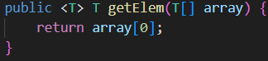
    - Return type: T
    - Here I am getting one array of type T, and returning the first value of the array which is ofcourse of type T only.
  - 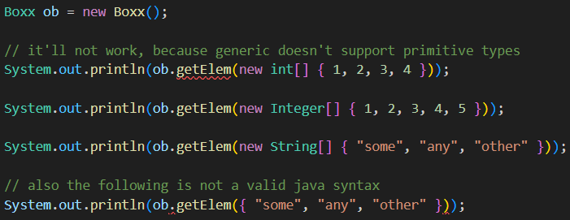
  - The first one is giving error because int[] is a primitive type array and generic doesn’t support primitive.
  - The last one is not valid syntax because Java never allows a raw array initializer as an expression.
  - {1,2,3} or {“some”, “any”, “other”} is NOT an object, NOT an array, NOT an expression. It is ONLY a shorthand allowed in one specific place: variable initialization. {..}.
  - In simple terms, {1,2,3} or {“some”, “other”} ..etc are shorthand for new int[] {1,2,3} or new String[] {“some”, “other”} only when it is being initialized to a variable. Apart from this, it is not valid anywhere else.
  - 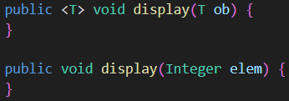
    - It is method overloading. If Integer is passed then the 2nd method will be called. Otherwise the first method will be called.
  - --------------------------------------------------------------------------------------------------------
  - 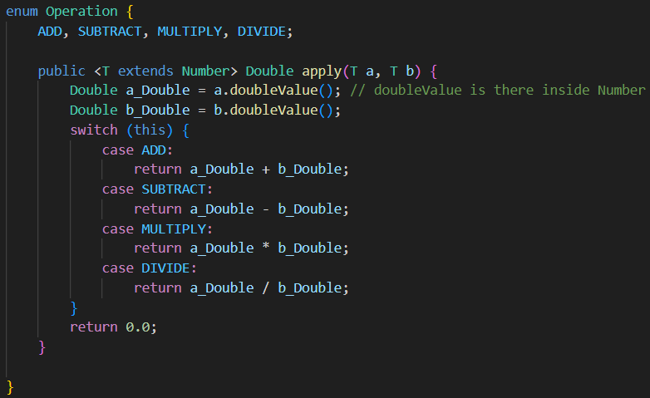
    - I wrote one generic method inside enum here. [ switch (this) ]
  - 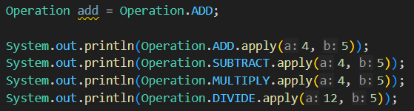
    - Now we can use like this.

Wildcards in Generics
- Wildcards ( ? ) is used in method arguments or class definitions to represent an unknown type.
  - The type can be specified later or be more loosely defined.
  - If you are just doing read operation and not returning anything then wildcards is useful.
- In the below example, you can see, we are only reading the values.
  - 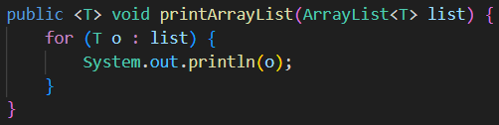
- We can write like the below:
  - 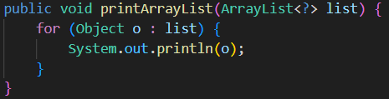
  - No need to explicitly mention <?> before void just like the generic type T.
- In the below example, we are returning something.
  - 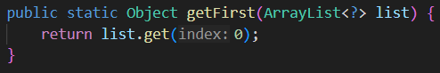
  - Here, Object is the parent class of every class, so it’ll not give any error in the method.
  - But, we need to explicitly downcast in the function call step.
  - If we don’t downcast that, it’ll give error.
- So, the method should be using generic only.
  - 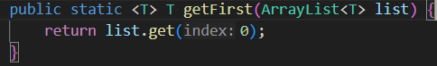
- NOTE
  - Arrays.asList() returns List type.
  - 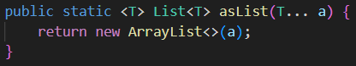
  - As the return type of List<T>, and its returning ArrayList<T> so its basically doing upcasting (which is not needed to be explicitly mentioned).
  - So, there can be 2 possibilities:
    - 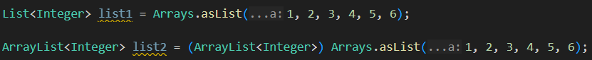
    - If you don’t downcast it then it’ll give error just like below.
  - One more thing, as the generic doesn’t support primitive type then how are we able to pass normal 1,2,3 .. inside the function as arguments.
    - You can see, in the definition of asList method, (T… a) is mentioned.
    - So, the int values are getting auto-boxing by default.
    - NOTE: We are not assigning T as int, but we are passing the int value; which are being converted to Integer.
    - The above is same as the below:
    - Integer.valueOf is used to convert int to Integer.

- So, in shorts: when only read-only operation is being done and not returning anything; then wildcards can be used.
- It can also extend some class just like generic T
  - 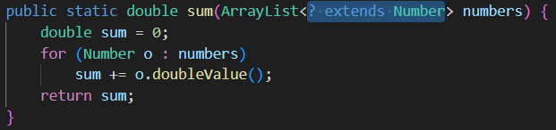
  - It is upper-bound.
  - It means max Number class can be given. Parent of Number cannot be given.
- Below is the example of lower-bound
  - 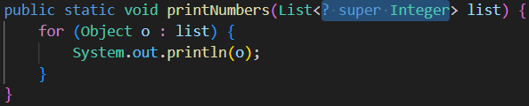
  - super keyword is used for this.
  - NOTE: You cannot write T super Integer for generics.
- In case of upper bound, we can’t do write operation like below.
  - 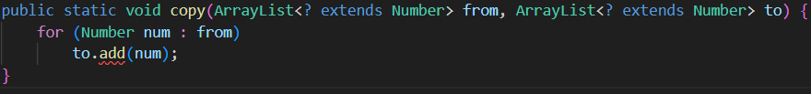
  - The to list can be of Integer, Double or anything.
  - Lets say the from list is of type Integer.
  - Here you need to know the type of ? in to list to store the array i.e. the type of to is Double, and you are trying to store Number type (which is super class of Double and Integer), but to store Parent type in Child type you need to do downcast explicitly. Which is not possible in this case without knowing the exact type of to list.
  - So, if we know the sub-class then we can downcast and perform the write operation.
  - So, we can perform write operation in lower-bound type of wildcards.

